Request for Proposal (RFP): A self-service consumable Third-Party Landing Zone (3PLZ) solution scalable to 1000 tenants for CVS Health

1. Executive Summary
Communication with our business partners is foundational to our success. Supporting this communication comes with some risk, this RFP in partnership with our vendors, looks to manage this risk in a transformative approach to delivering a connectivity solution to deliver a Third-Party Landing Zone (3PLZ) that enables secure, isolated, and auditable access between external vendors and partners to enterprise applications.
This architecture embraces the best elements of network security best practice: least privilege, segmentation, intent, and identity. Delivering a business-to-business connectivity solution built on a high-availability, fault tolerant VPN model to support secure communications exchange. Terminating in a no-access tenant (Virtual Landing Zone – VLZ), in which application teams can provide pattern based, per-service connectivity through application-specific proxies governed by connectivity service profiles.
Considering size and scope of the current 3PLZ implementation one critical delivery aspect is requirement that the solution be largely automated and consumable as a self-service solution that can be directly consumed by application development teams, extending the DevOps philosophy of “build, run, own” into the delivery and consumption of network security. Embracing a self-service delivery approach, empowers the application teams that “own” the 3P connectivity, to migrate existing connectivity themselves, while ensuring that the best security practices are maintained through a delivery framework that can also deliver enhanced capabilities and controls as needed going forward.

2. Business Objectives & Security Outcome Context
The enterprise requires a repeatable, compliant, and automated approach for third-party access to SFTP, VDI, internal web apps, and external SaaS. This solution must maintain least privilege, auditable access while reducing operational overhead through automation and self-service onboarding. Key drivers include compliance with SOC 2 Type II, ISO 27001, and the NIST Cybersecurity Framework.

3. Architecture Overview and Technical Functionality Need

The end-user does not require any technical understanding of the solution.
The solution can be consumed via a 2-Factor authenticated Web Portal or via API with an API certificate generated via the web portal (mapped to the 2-factor authenticated user).
The user can generate the IPSec Tunnel configuration required for the vendor or partner to establish connectivity based on the collection of a standard set of data points, that can be easily collected.
The user is not responsible for the security compliance of the solution. Once the service is established the solution can be maintained in place with little to no service disruption greater than 5 minuets
The solution can support access to “supported” applications, using enterprise issued credentials, certificates, keys, and passwords and if required separate credentials for 3rd Party Access and Enterprise Service access.

Architectural Components/Definitions

HA-FT IPSec tunnel
The end-state goal is to provide connectivity using a set of service patterns, to define per-tenant service-profiles,

Bla Bla Bla
Picture…..

Component | Technical Purpose | Security & Compliance Justification
IPsec IKEv2 Tunnel | Creates authenticated encrypted tunnels between gateways. | NIST SP 800-77, RFC 7296, FIPS 140-3 compliant encryption.
No-Access Tenant (VLZ) | Terminates tunnels without exposing internal networks. | NIST 800-207 Zero Trust principle; CIS Control 13 Segmentation.
HTTPS Application Proxy (Envoy/HAProxy) | Service-Profile gateway with mTLS enforcement. | NIST AC-4 and ISO 27001 A.13.1.3 Network Segregation.
SSH/SFTP Application Proxy  (Teleport, JSCAPE MFT, OpenSSH) | Provide
BGP Per-Service Routing | Advertises only service-specific prefixes. | CIS Control 6 Least Privilege Access.
Split-Horizon DNS | Resolves internal vs public paths via policy. | NIST SI-4 Monitoring, RFC 8499 DNS Security.
PKI/mTLS Identity | Authenticates all connections using certificates. | NIST IA-2, ISO 27001 A.9.4 Access Control.
Automation & API | Enables Terraform/IaC provisioning. | NIST SP 800-218 DevSecOps and CIS Control 4.
Observability & Logging | Exports per-tenant logs and metrics to SIEM. | NIST AU-12, ISO 27001 A.12.4 Logging and Monitoring.

4. Use Case Scenarios and Security Best-Practice Alignment

Secure File Transfer (SFTP/Sterling)
  - Use Case: Vendors exchange files via SFTP or IBM Sterling with PKI-secured sessions.
  - Relevant Standards: NIST SP 800-171 3.13, CIS Control 14, FIPS-compliant encryption.

Collaboration Platform Access: (M365, eShare, Slack)
  - Use Case: External users access collaboration tools through proxied, audited channels.
  - Relevant Standards: ISO 27001 A.13.2.1, NIST AC-2 Account Management.

Virtual Desktop Infrastructure (VDI)
  - Use Case: Third-party workers use Citrix/Microsoft VDI via per-tenant mTLS proxies.
  - Relevant Standards: NIST 800-207 ZTNA, ISO 27001 A.9.2, CIS Control 5.

- Web Application and API Integration for internal and external hosted Applications
  - Use Case: External apps integrate securely with enterprise APIs via mTLS and JWT.
  - Relevant Standards: NIST SP 800-95, OWASP API Top 10, CIS Control 16.

5. User Workflows (Consumer)
Tenant Creation Workflow

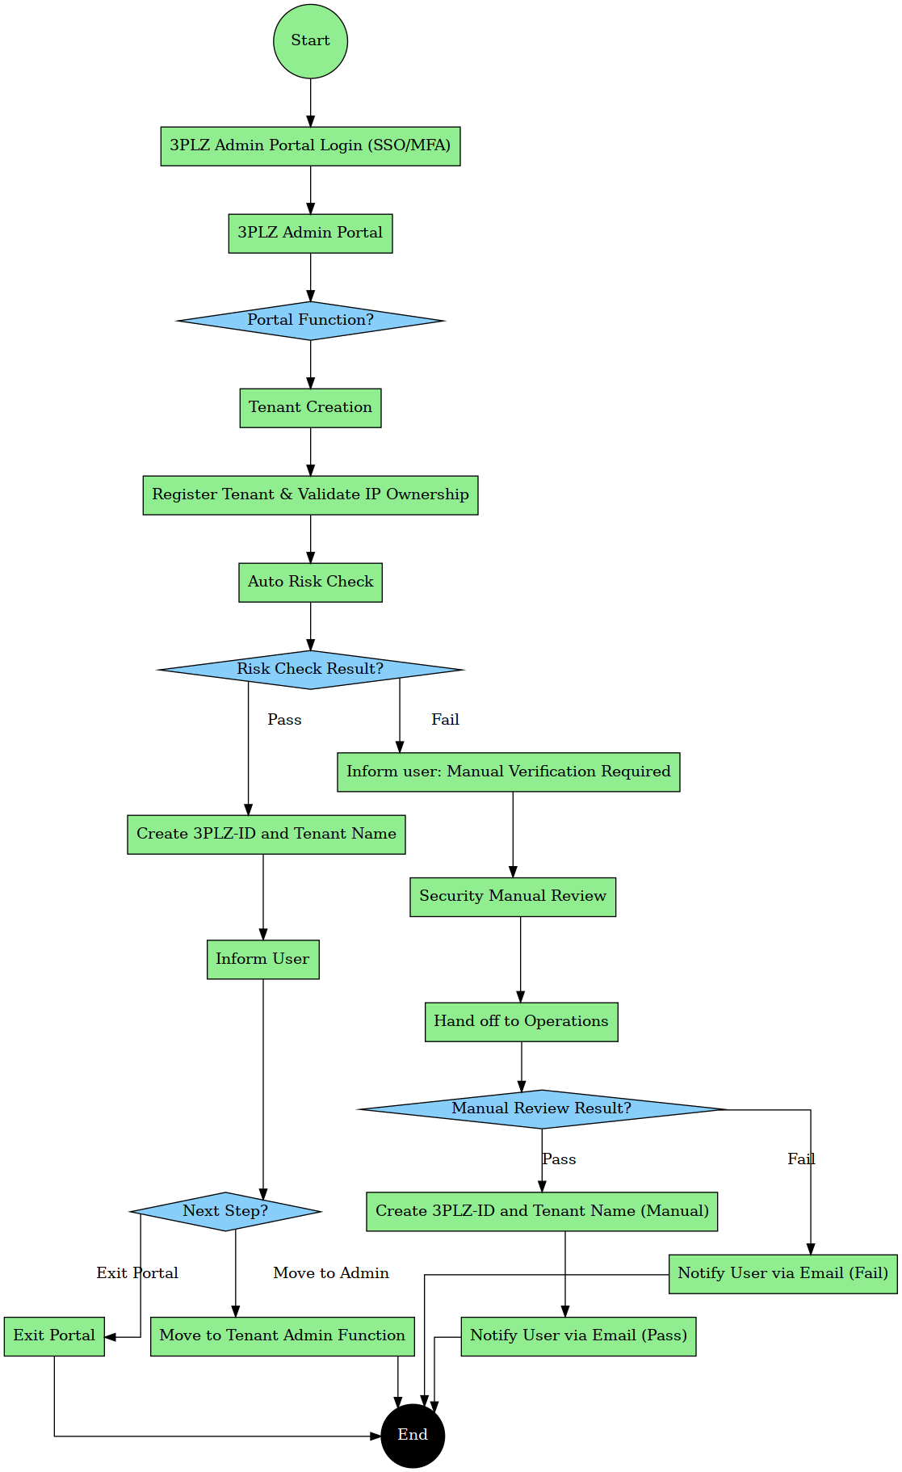

Tenant Admin Workflow:

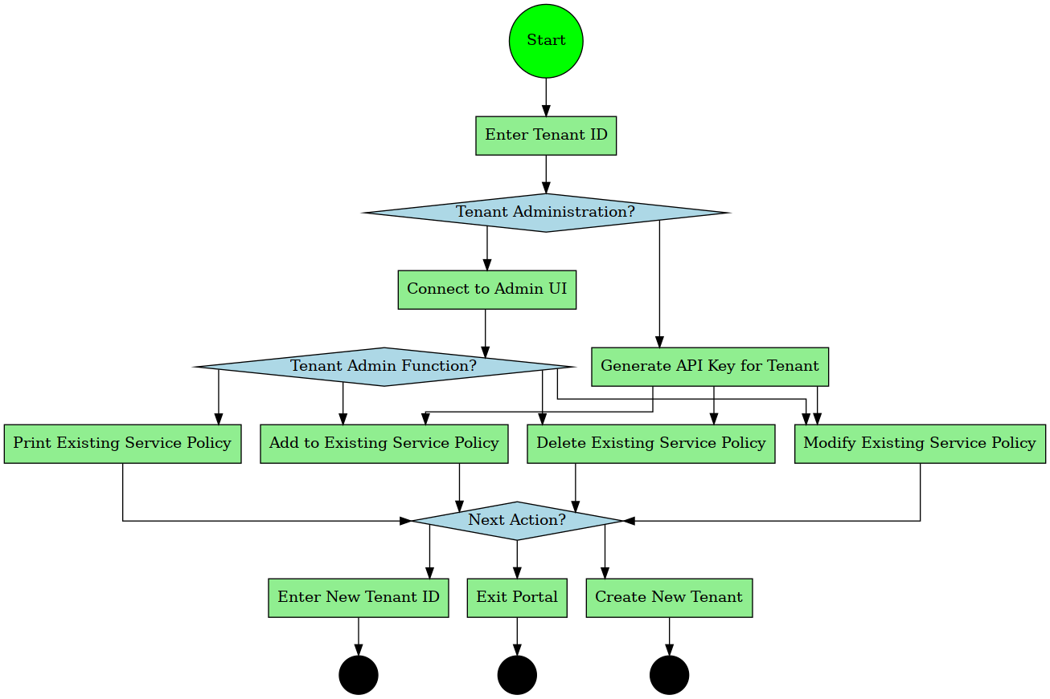

Tenant

6. Security Best Practices and Control Mapping

Framework Control | Implementation in 3PLZ | Evidence / Artifact
NIST 800-207 (ZTNA) | VLZ No-Access Model & Service Proxies | Network Design Documents
ISO 27001 A.13.1.3 | BGP Per-Service Routing | Routing Policies & LLDs
CIS Control 6 | DNS Views & Service Profiles | DNS Configurations
SOC 2 (CC6.6) | Per-Tenant Logging to SIEM | Audit Logs & Reports
NIST SP 800-57 | PKI Lifecycle Automation | Certificate Repository & Rotation Policies

7. RFP Deliverables

- Vendor specific technical solution proposal for the delivery each technical architecture components listed in section 3.
- 1. Cloud based Tenant Administrative Portal – Access should be via Web CLI and API
- Access via SAML with two-factor authentication
- Portal needs to tie-into CVS PKI and Secret Management Platforms for VPN Certificate, mTLS certificate and SSH Key management support
- 2. Automation for RC hardware configuration, delivery via secure mail or WebUI
3. Compliance Mapping Document (NIST, ISO, CIS).
4. Runbooks for PKI rotation, onboarding, and incident response.
5. Interoperability guides for Cisco, Palo Alto, Fortinet, Arista, and strongSwan.

8. Appendix

Artifact #1: NGNIX Configuration for mTLS with GET and PUT Support
server {
listen 443 ssl;
server_name api.example.com;

# Server certificate and key
ssl_certificate /etc/nginx/ssl/server.crt;
ssl_certificate_key /etc/nginx/ssl/server.key;

# Trusted CA for client certs
ssl_client_certificate /etc/nginx/ssl/ca.crt;
ssl_verify_client on;

# Optional: restrict to specific methods
limit_except GET PUT {
deny all;
}

location / {
proxy_pass http://backend-api;

# Optional: pass client certificate info to backend
proxy_set_header X-SSL-Client-Verify $ssl_client_verify;
proxy_set_header X-SSL-Client-DN $ssl_client_s_dn;
}
}

Artifact #2. CA Management Script

Artifact #3

The platform must enforce Zero-Trust segmentation—no direct layer-3 access between remote and corporate networks—and align with NIST SP 800-207, ISO/IEC 27001:2022 A.5/A.8/A.12, and CIS Controls v8 #3 (Access Control).

